Great job so far, we would like to move you to the next phase of our process.

For the next step in the process, we have a take home assignment (THA) that has been used for our native app mobile engineers for quite some time that we would like you to complete. We view this as a great way for you to demonstrate the kind of approaches you take when writing iOS apps. Please do not use any 3rd party libraries, cocoapods, carthage, Alamofire, etc., for this project.

We’ll be looking at your code style, use of data structures, collections, and overall Platform knowledge. **Use Swift**.

When finished, please upload your source code in github and let us know so we can review it. We will also discuss about the design and implementation during the onsite rounds.

# Bus Route App

Routes App shows a list of buses routes and when user taps in one of the items in the list, it should open the route’s details. In the details screen, the user should have the ability to view next/previous route by swiping left/right (e.g. Gmail app). More details can be found in the mockup below.

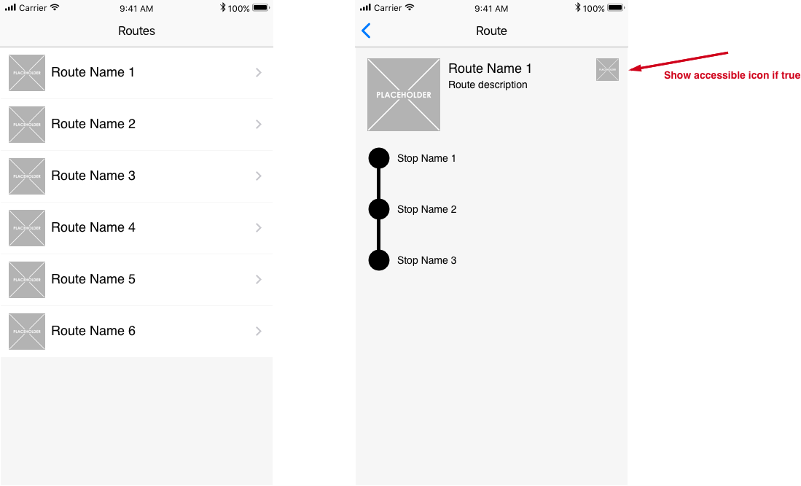

# REST api

# <http://www.mocky.io/v2/5a0b474a3200004e08e963e5>

# Resources

Accessible icon: [https://www.iconfinder.com/icons/118812/accessibility_desktop_preferences_icon - size=128](https://www.iconfinder.com/icons/118812/accessibility_desktop_preferences_icon#size=128)

Dot icon: [https://www.iconfinder.com/icons/298849/dot_primitive_icon - size=128](https://www.iconfinder.com/icons/298849/dot_primitive_icon#size=128)

Bus placeholder icon: <https://www.iconfinder.com/icons/134180/bus_icon> (Use this icon whenever a route has ‘imageUrl’ equals to null)

Vertical line: <https://www.onlinewebfonts.com/icon/357609>